**Declaration of Original Work**

We/I, Lorenzo Luis Palay of section S11B, declare that the code, resources, and documents that we submitted for the [1st/2nd] phase of the major course output (MCO) for CCPROG3 are our own work and effort. We take full responsibility for the submission and understand the repercussions of committing academic dishonesty, as stated in the DLSU Student Handbook. We affirm that we have not used any unauthorized assistance or unfair means in completing this project.

By signing this declaration, we affirm the authenticity and originality of our work.

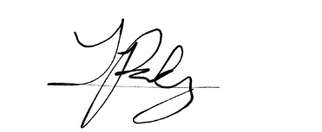

28/06/2025

___________________________

Lorenzo Luis R. Palay

12209066